Parents,
We are excited to support your student with our Hybrid Learning plan. Thank you for your patience, support and understanding as we have worked diligently to get things prepared.
All families are required to digitally sign the Device Agreement found in your myDSD portal. In the event we do go into closure, or rolling closure, this will allow us to quickly provide a device for home if needed.
To Sign those documents please follow the instructions below:
- Log into your myDSD parent account using the email and password you created upon set up.
The myDSD portal is found in the top righthand corner of the District or school web page.

- Once logged in, you will see your student’s information and a tool bar at the top of the screen. Select “TOOLS”
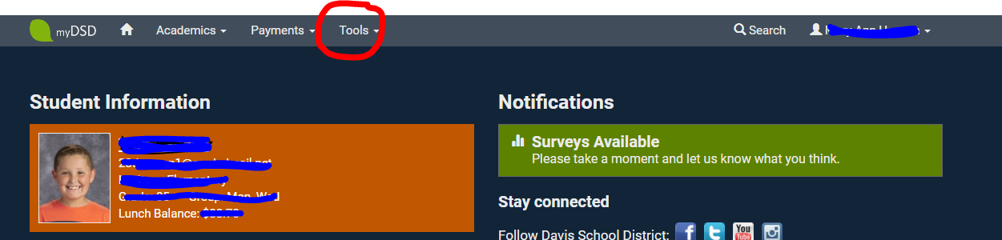
- The menu will open, and you will see a “SIGN DOCUMENT” tab. Select and proceed to read and digitally sign each of the agreements located there.
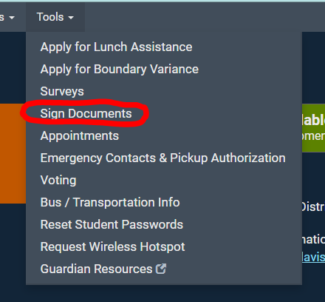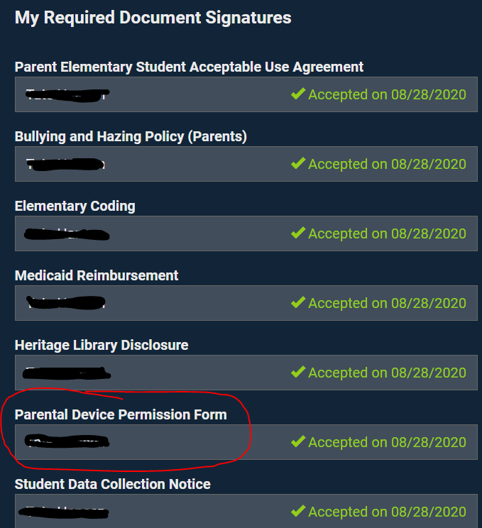

We recognize some families may not have device access at home. If you will need a device to travel between school and home, please complete the items below.

- If you need a school device to support schoolwork at home, please email your respective teacher directly no later than Tuesday September 1st. This will help us prepare those devices.

- Be sure to electronically sign both the Acceptable Use Agreement and Device Agreement through the myDSD online portal. This will be required before the device can be checkout out.

- An optional Device Insurance plan is now available. If you choose to insure your device, you will have 14 days after the date of issue to pay for the plan. Plan cost and details are attached. Payment can be made via myDSD under “optional fees”.

- Students K-2 will be issued an iPad for home to school use. The iPad will be sent home fully charged and will NOT be sent with the charging block. It is expected that the device will come back each school day for support and to be charged. It is a school tool and is expected to be used as such. Please always keep it in the case provided, with all labeling attached. Parents are responsible to monitor and support their student’s use.

- Students 3-6 will be issued a laptop for home to school use. The laptop will be sent with the charging block. It is expected that the charging block will remain at home, and the laptop will return to school each school day fully charged for support. It is a school tool and is expected to be used at such. Please always keep it in the case provided, with all labeling attached. Parents are responsible to monitor and support their student’s use.

- School to Home to School. Please ensure your student is bringing their device back and forth tucked safely in a backpack. Remind them that caution should be used as the device is brought back and forth. Damage due to negligence will be the responsibility of the student/family.

- Cleaning and care. Food and drink are not allowed near the device. Please enforce this. Devices can be cleaned and should be cleaned frequently. This can be done using a solution of 50% Alcohol/50% water. Place solution in a spray bottle, lightly spray a soft cloth, and wipe down the screen and/or keyboard. Never spray the device directly.

- Issues with software/applications/online tools please work directly with your respective teacher. Issues with hardware, damage, loss, theft, replacement, please contact the school who will then put you in contact with the school technology specialist for instructions on repair/replacement.

