You Are Making a Greater Impact than You May Think
-A few supportive thoughts from a veteran principal

I recently received this note from a student whom I’ll call “Gage,” because that is his name.

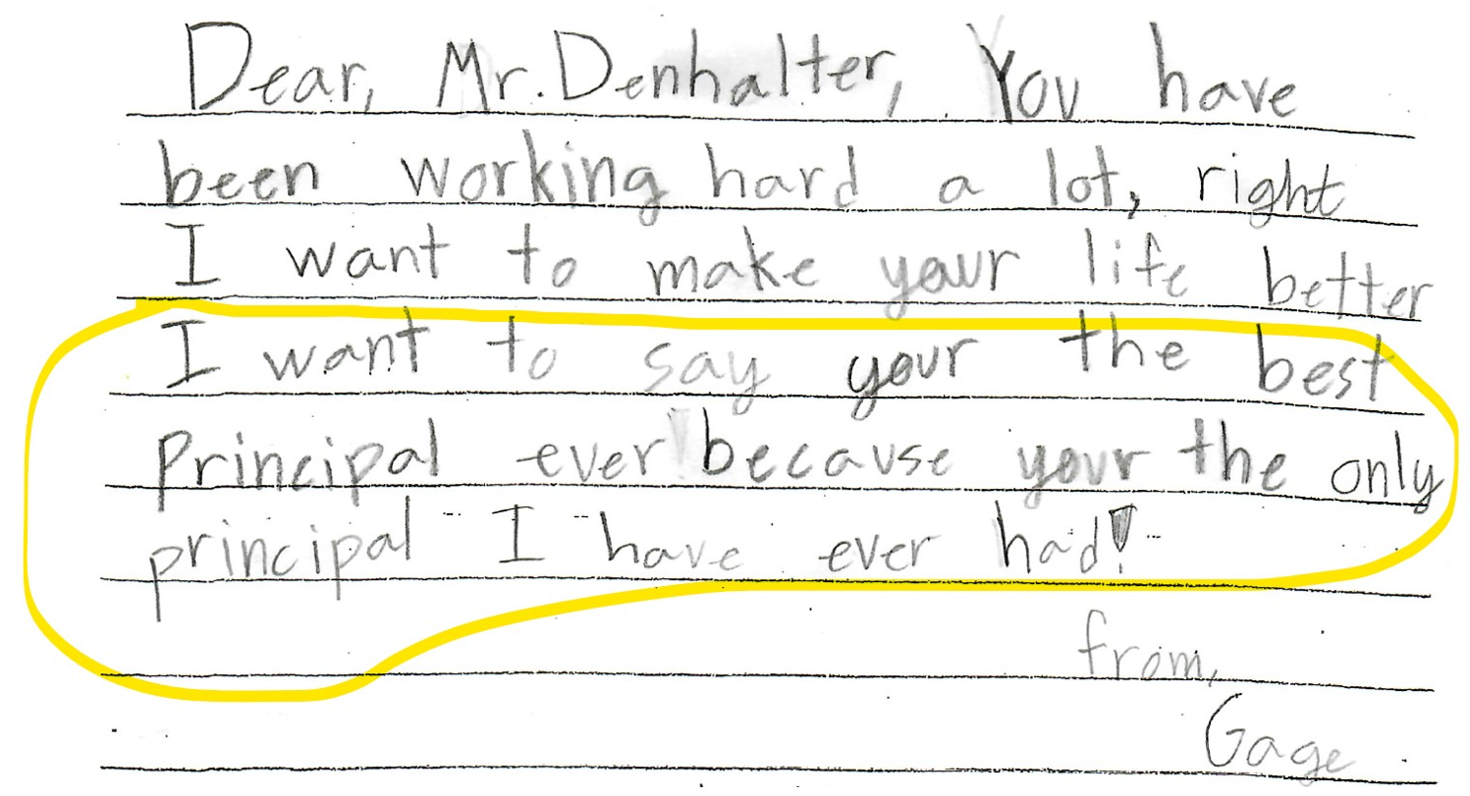
I hung that note up in my office because I appreciated the unintended humor. I knew Gage’s kind intent and his note makes me smile. I love the children and I enjoy trying to view things from their perspective. Serving the children is my reason for choosing my career path in education. Notes like this and interactions with the children keep me grounded.

I’ve been around a little while. I started working as a playground supervisor in an elementary school in 1989 and discovered fulfillment in teaching the children. I advanced in several educational positions in my career until reaching my current position as an elementary school principal. I recognize that over the years, especially over just the past few years, the job has changed. It has become increasingly more demanding. As a fellow principal, you know this. You are experiencing it. I recognize that your job is tough. Responsibilities and accountability have increased. Society expects more and seems to tolerate nothing less than perfection. You are expected to be a pillar in society, to rise above criticism and targeted negativity, and to do it with predictable consistency and a pleasant smile on your face. Yes, the job is tough, but as former school director Craig Poll was known to share many times, “If it were easy, anybody could do it.” As difficult as it all is, speaking collectively, I think you are doing an amazing job.

Crossing the unspoken barrier between teaching (or whatever your position may have been prior to the principalship) to school administration, separated you somewhat from the formal and informal teacher support network. Some principals may be concerned about reaching out for support when it is needed. Some may not want to be judged unkindly or perceived as being incompetent or not being all-knowing. Yes, principaling can be lonely, complicated, and may often feel overwhelming. There are ways to increase effectiveness and to stand emotionally on solid ground.

Find your trusted supports and create reminders that help you remember your leadership vision and reasons for entering this profession. Some of my greatest supports come from trusted fellow principals. I find it so valuable when principal meetings end near lunchtime. Since we should be eating lunch anyway, I encourage you to resist the pull to quickly return to your school and to join your fellow principals for lunch. You will form professional friendships, receive advice from those who have already experienced the challenges you are now facing, and perhaps you may have an opportunity to offer advice and support to other principals. I believe these informal after-meeting lunchtime visits provide me with more support than maybe anything else I do as a principal. If nothing else, you will realize you are not alone and that perhaps the challenges you are facing are not nearly as difficult as those others may be facing.

A few of my principal friends organize and run a Principals Partnership Network (PPN). While the visits I have participated in seem fairly informal, these meetings are organized formally and held in several regions across the state. My experience is that they are comprised of elementary principals from a variety of settings, which I find adds unique and interesting perspectives. In my visits, we have discussed topics such as improving attendance, meeting various student needs, overcoming the demands of our positions, and other challenges. I have found it to be insightful to hear various perspectives and approaches others have taken that both have and have not worked. Since these meetings are informal it is ok to attend when you can. You can find your local PPN by searching for “PPN” under PD Courses in Midas education https://usbe.midaseducation.com/.

Recently, I have been meeting weekly with my administrative intern, my school’s English Language Arts Coordinator (aka reading specialist), and my school’s counselor. We decided to call this our “ARC” (admin, reading, counselor) team. Our meeting purpose is not only for me to provide support for them in their roles, but to collaborate by discussing the overall needs of the school with the mindset of striving for continual improvement.

As important as I know our role is as school principals, and even though I really do realize I’m having a positive impact on the emotional and academic lives of my students, I sometimes overlook the many great things that are happening and listen too closely to the few voices of pessimism and criticism. I often become my own worst critic as I sometimes struggle with keeping up with all the many demands and deadlines. To keep sane, I need to deliberately and strategically maintain or regain perspective and recognize the growth and good that is happening.

Again, I encourage you to find what keeps you grounded. Sometimes I feel overwhelmed with all the challenges that seem to come my way, not only in waves but often in tidal waves -and usually when it’s high tide. If you are like me, there are times, perhaps many times, when you may feel ready to throw in the towel. You may even be spending a few minutes every week wondering why you entered this profession and what else you could be doing for your career. My quick fix for when I am feeling this way is to either observe an outstanding teacher who is consistently wonderful or to interact with the children in the lunchroom or playground. Being with them helps me remember why I chose this career path. For me, it all comes back to the children, and thinking about the children always helps me regain a healthy perspective.

You may find it beneficial to reach outside of your own education world. One way that has helped me overcome my own feelings of inadequacy or job-related struggles is to be a support for others. I try to encourage others by helping them recognize the great person they are and to see the great work they are doing. In fact, writing and sharing this article helps me because I hope and believe something I have shared may help you.

Finally, keep learning. Many say they are life-long learners because they always have more to learn. Remember that in our profession, this pursuit of learning extends much further than academics. Accept that you may not have it all figured out, yet, but be determined in striving to continually improve.

We’ve got this! Now go spend a few minutes with the children at recess.

Darryl Bond Denhalter, Ed.D.
Principal, Columbia Elementary
Kaysville, Utah
ddenhalter@dsdmail.net

Most Recent Publication:
Denhalter, D. B. (2020). Holistic Approaches to State School Grading Systems. BYU ScholarsArchive.
