Meeting notes from October 22, 2020
Welcomed new members Kristy Grantonic and Melissa Fredrick, and gave an explanation of what we do on community council, and how we use the needs of the teachers and students to guide where we allocate the Trustlands money each year. We will not meet again until January unless needs arise. Then we will meet monthly if not more often to determine where this year’s money can best be spent.
Last year money was used to fund Structured Recess as well as Math Aides. Both programs have proven to be very successful. The Structured recess has dropped behavior problems significantly, and the Math aides help with Imagine Math program. Our school won the State Imagine Math award last year.
Discussed what we want to see our children accomplish next year to guide our School Improvement Plan. Completed the Venn Diagram with input on what Skills, Experiences, and Dispositions we want our children to learn. Here are a few key points from this discussion.
Basic Skills-math, reading, SCIENCE, keyboarding
Arts- Field trips, performing arts, visual arts
STEM
Real World Experiences- not just watching using technology
Direct Instruction
BALANCE- not too much technology, not too much independent work, not too much push on one subject.
Social Skills- Team Work and collaboration
Communication and practicing skills at home, Resiliency, Respect, Compassion, Confidence
Purposeful learning!
Our homework is to look at this list and add to it with our families. Come next meeting prepared to discuss again.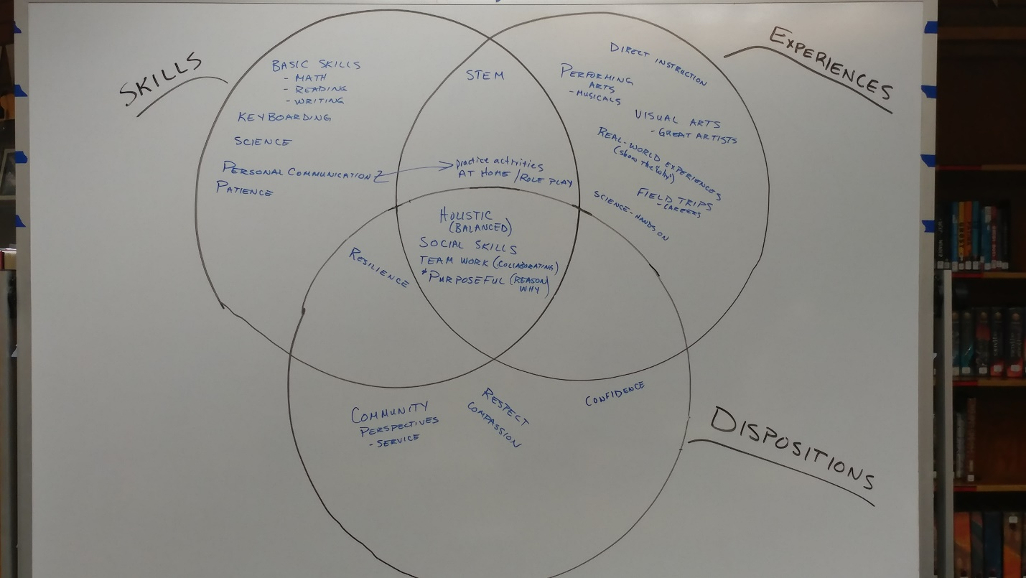
Annette brought up the idea of creating a survey to send out to parents about how much technology they would like to see utilized within the school. She will with a few other members create a survey and send it out to the rest of the committee to edit before sending out to the parents. We will also have teachers send out to parents how they each use technology in the classroom to give parents a better idea of how much technology is being utilized.

Jen and Amy discussed the money that was allocated to Kindergarten aides does not seem to be being used right now. The Kindergarten classes are very large and are in a desperate need for more aide support. Right now they are receiving 12 hours of aide time as well as 4 additional hours given them. The proposal is that we use the aide support allocated to SPED and move it over to Kindergarten or take some of the support that is not being used by 1st grade currently. We would need to discuss how this can be utilized since the Kindergarten classes need continuity within their aides.

Follow up note: After consulting with the kindergarten teachers and considering the 16 hours of additional aide support currently provided, they expressed that they feel they have all the support they currently need. We will continue with the original School Improvement Plan (SIP) and allocate aide support to the special education classes as outlined on the SIP.

